Lab 6
Ashmitha Murali
Prof. Alex Yang
Verilog HDL Lab EE461L
4th November 2025

Q1a. “if" Conditional statements:
Result:
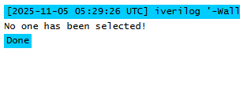
None of the statements were selected because since X and Y have x and z in them, the entire X and Y would be evaluated to ‘x’. When using == or != this would not satisfy the if condition as it would evaluate to x(unknown).

Q1b.
Result:
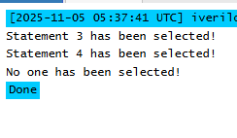
Here both statement 3(X!==Y) and statement 4(X===X) were selected. This is because the === and !== statements compares the values even with x and y included within them. This would do a bit by bit comparison along with x and z values and hence the if condition satisfies X!==Y and X===X cases.

Q2. Continuous assignment with conditional operator.
- With Z=(X==Y)? 1'b1:1'b0;
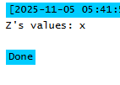
X and Y both evaluate to x since they have x and z bits in them. Because of this the condition X==Y condition is unknown and the Z value is set to unknown as well.
- With Z=(X===Y)? 1'b1:1'b0;
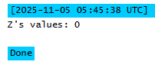
With X===Y, the condition is not satisfied and hence the else path which is 1’b0 is assigned to Z.
- With Z=(X!==Y)? 1'b1:1'b0;
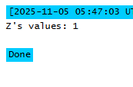
With X!==Y, the condition is satisfied, since it tests along with x and z values and hence the if part 1’b1 is assigned to Z.

Q3. "case" conditional statement
Result:
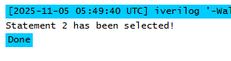
It is selecting statement 2 because case matches exactly for the bits x and z. Since X is exactly 4’b101X, statement 2 is selected.

Q4a. casex" conditional statement
Result:
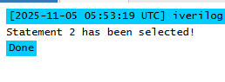
Casex treats both x and z as don’t cares. In this scenario, since we are checking 4’b10xx, the last two bits are considered don’t care in casex statement and the condition is evaluated to be true if the first 2 bits match and hence we get Statement 2 as output.

Q4b.
Result:
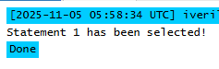
In this code, statement 1 which is 4'b???1 gets selected. This is because ? is considered as wildcard and this can be any value. The casex statement is only comparing the last bit and sice the last bit in X is x, it is considered don’t care and the statement is evaluated as true.

Q5. “casez" conditional statement
Result:
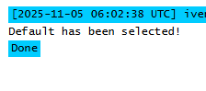
In this module, none of the statements were satisfied. This is because casez only matches z values to 1,0 or z and does not match x values. There is not condition that satisfies the X value of 4'b1x00.

Q5b.
Result:
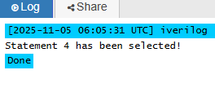
In this module, the wildcard matches all possible values of 0,1,x and z. Because of this the condition 4'b1??? matches the X value of 4'b1x00 and hence statement 4 is selected.

